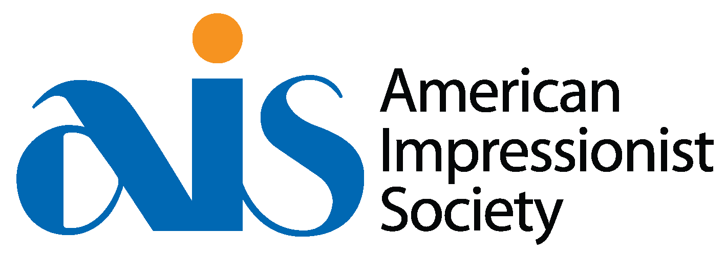
AIS Workshop with James Richards AISM
Supply List
May 10-11, 2022 Taos, New Mexico
Workshop location: Fechin Studio at Taos Art Museum/Fechin House
Paint Colors: (Any brand)
Titanium White
Cadmium Yellow Light
Alizarin Crimson
Ultramarine Blue
Viridian Hue
Burnt Umber
Medium:
Gamsol
Solvent Free Gel by Gamblln
Brushes:
Large/Medium/Small size in each (ie 3, 8, 12) of the following - Rosemary Evergreen flats and/or Philberts and Rosemary Combers
Rosemary Classic Bristle - Size 8
Canvas:
9x12 and smaller - mix it up! James prefers Centurion and Claessens canvas, which he prepares himself. Remember that you will be encouraged to paint multiple paintings. Keep your canvases or panels small enough to not get hung up on one painting every day.
Plein Air Easel
Palette
Palette Knife
**Please note that this is what James uses and is a recommendation only. Feel free to substitute or bring whatever you are comfortable with. If substituting colors, please bring a full set.**
Questions? Contact Liz Ahrens, AIS Executive Director 231-881-7685 aisdirector1@gmail.com www.americanimpressionistsociety.org

