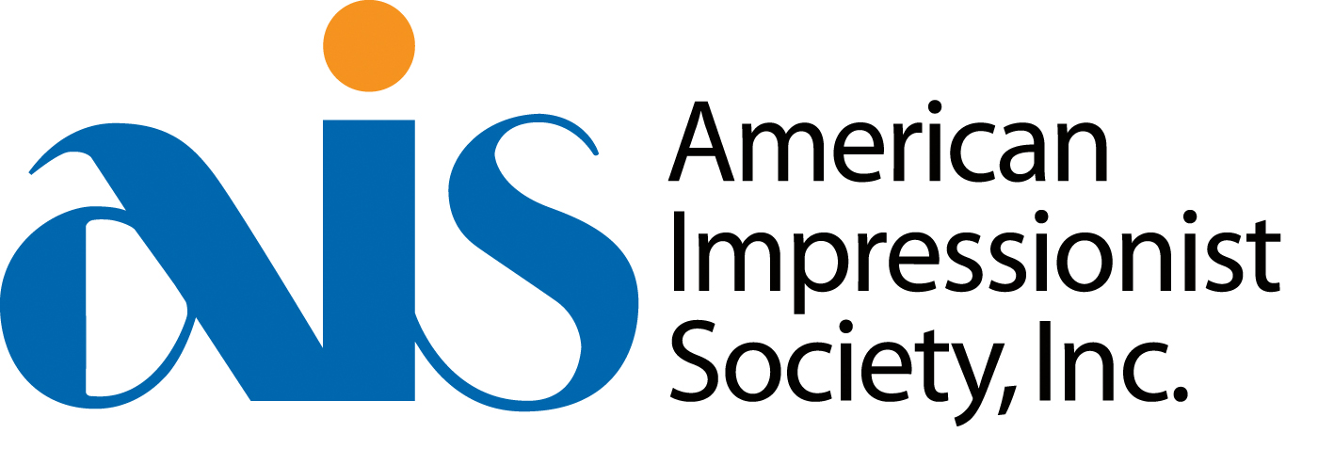

4th Annual “Impressions: Small Works Showcase” National Juried Exhibition

March 6 – April 4, 2020
RS Hanna Gallery, 244 West Main St, Fredericksburg Texas
Judge of Awards: Nancy Bush, AIS Master

A complete list of events/schedule will be available on the AIS website and social media platforms as soon as they are confirmed. All current paid AIS members will receive updates via the AIS email newsletter as well.

PLEASE READ CAREFULLY AND FOLLOW INSTRUCTIONS COMPLETELY AND ACCURATELY. THERE CAN BE NO EXCEPTIONS TO DEADLINES OR REQUIREMENTS.
AWARDS: Best of Show $4,000 cash with other awards to be announced
ELIGIBILITY/REQUIREMENTS: There can be no exceptions to deadlines, specifications or rules.
MEMBERSHIP: Must be a current (or new) member of AIS and must be a legal US resident to be eligible to enter. 2020 membership dues of $60 must be paid prior to entering. To join online or to download a mail-in membership form, visit www.americanimpressionistsociety.org.
MEDIUM: Oil, Pastel, Acrylic, Watercolor or Gouache. No mixed media, photography, digital or any other media. No digitally manipulated work, painted giclee prints or any other type of reproductions, no manipulated or painted over photos. Any artist whose work is determined to be in violation of this rule will be disqualified, will forfeit any awards received and will be banned from any and all AIS exhibitions for the following three years.
WORK REQUIREMENTS: Work must be original in concept and execution, impressionistic in style, must have been completed within the last three years. Work done in ANY class and/or under the guidance of an instructor is not eligible for entry. Work painted from reference photos must be created from the artist’s own photographs, not from any other photo source, copyrighted or not. Entries must not violate any copyrights. Entries may not have been exhibited in any previous AIS show. Work that was entered but not accepted into previous AIS shows may be entered again as long as they meet the above requirements.
SIZE & QTY: This is a small works exhibition. Maximum size (excluding frame) is 12x16 inches (maximum length on the shortest side=12 inches, maximum length on the longest side= 16 inches). Minimum size is 6x6 inches. Two paintings may be submitted. Maximum of one painting per artist may be accepted into show.
FRAMING: Work must be suitably framed in a fine art gallery-quality wood frame, wired and ready for hanging. Gallery strongly urges using “D” rings in wiring your painting. No metal frames, gallery wrap canvases or sawtooth hangers. Unsuitable or damaged framing will disqualify. Repair or replacement of frame is financial responsibility of artist. AIS and Gallery are not responsible for damage caused by works framed with glass. Plexiglass is recommended.
LIABILITY & AGREEMENT: All entries will be made at the risk of the entrant. Care and caution will be exercised in the handling of all art work. Gallery is insured however neither AIS nor Gallery may be held responsible for loss or damage. Artists are responsible for insuring their work during transit. Work will be insured while on the Gallery premises at 60% of the retail value as stated by the artist on their application and on the inventory list. Digital images are assumed to be accurate representations of the entrant’s original artworks. Artwork that differs markedly from the submitted image will be disqualified. The artist retains copyright to his/her image(s), however, by submitting to this show, artist agrees to allow AIS and Gallery the use of the images for publicity (including future AIS event promotion) and archival purposes. There are no refunds of entry fees. Submission of entries and entry fee constitute agreement with all conditions set forth in this prospectus.
SALES COMMISSION: Artist 60%, Gallery 40%. All work MUST be for sale and must be priced according to your standard pricing – OVERPRICED WORK WILL BE DISQUALIFIED. NO PRICE CHANGES WILL BE ACCEPTED ONCE YOU SUBMIT YOUR ENTRIES –please double check your entries for accuracy of information. An artist who withdraws an entry after acceptance into the exhibition shall not be eligible to enter any AIS exhibition for the two succeeding years. Any accepted work which is presold MUST be included in the show. Presales must be completed through the Gallery and the Gallery commission applies.
ENTRY FEE: $39 for one painting or $49 for two paintings, to be paid with credit card through Paypal through the Juried Art Services site.
ONLINE ENTRY: All entries must be submitted online at www.juriedartservices.com
2020 AIS “IMPRESSIONS: SMALL WORKS SHOWCASE” EXHIBITION CALENDAR
Please mark these dates on your calendar. No exceptions can be made. Exhibition begins March 6th and ends April 4th.
Nov 1-Dec 2: Digital entries accepted at www. juriedartservices.com
Monday, Dec 2: Digital Entry FINAL Deadline at JuriedArtServices.com, midnight central time (PST). Due to the extremely high number of last minute entries, we highly recommend entering well before the final deadline to avoid possible last minute issues that can and do arise. Please plan ahead.
January 8, 2020: Jury results will be emailed to entrants and made available on the AIS website
Feb 17-Feb 21: Artists ship work to RS Hanna Gallery, 244 West Main St, Fredericksburg TX 78624. Phone 830-307-3071. To hand deliver, please call gallery to make arrangements. Artists must provide a prepaid return shipping label for the return of unsold work. Crate fee of $25, payable to the gallery, is required to be included. Crate fee will be waived for artists using MasterPak or AirFloat shipping boxes. Artwork will not be hung until crate fee (if not using MasterPak/Airfloat box) and return shipping label are received.
Feb 21: Last day for accepted works to arrive at gallery, either shipped or hand delivered.
March 3-5: All Member Paintout. Participants may show one framed painting created during the paintout at a Wet Wall exhibition/competition to be held at a location to be announced. Size limit is 12x16 maximum and 6x6 minimum. Separate awards will be given for the Wet Wall competition. Complete details will be posted on the AIS website when finalized.
Friday, March 6: Opening reception at the gallery 6 to 8pm.
March 4-6: One day workshops – details on AIS website when finalized.
March 7: Educational programs/lectures at the gallery
April 3: First Friday Closing Reception 6 to 8pm.
April 4: Last day of exhibition
April 26: Unsold work shipped back to artists. Note that this is the final shipping date-not the date for paintings to arrive back to artists. Hand delivered works must be picked up no later than April 11th or make arrangements with the gallery if that is not possible.
Lodging: Special rates will be available and will be published on the AIS website.

Our goal: “To promote the appreciation of American Impressionism through exhibitions, workshops and other media.” Membership is open to American Impressionist artists who are legal US residents anyone who wishes to support American Impressionism. You must be a legal US resident and a member in good standing (2020 dues paid) to enter the exhibition. To join visit www.americanimpressionistsociety.org. AIS is a 501(c)(3) not-for-profit corporation.
QUESTIONS? Debra Joy Groesser, President/CEO americanimpressionistsociety@gmail.com
Cheryl St John, Vice President cheryl@cherylstjohn.com

American Impressionist Society Inc.
PO Box 27818, Omaha NE 68127 (402) 592-3399 www.americanimpressionistsociety.org
americanimpressionistsociety@gmail.com

