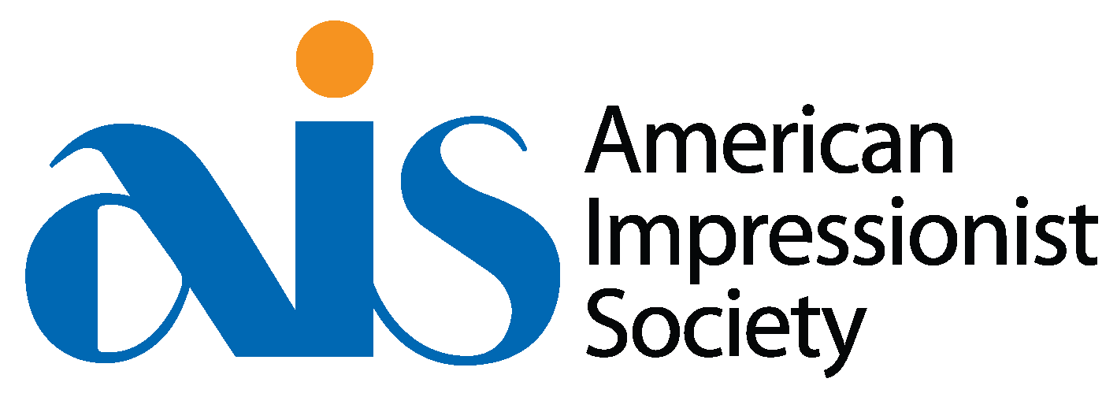
SUPPLY LIST DAN BECK AISM WORKSHOP 2024
Dan typically works with a limited palette but encourages a painter to choose a warm and cool of each color for his palette depending on the light situation and desired color schemes:
Reds: cadmium red (Med or Light), permanent rose or alizarin crimson
Yellow: cadmium yellow medium or yellow ochre, lemon yellow or cad yellow light
Blues: phthalo blue, ultramarine blue
Greens: viridian green
Ivory Black
Titanium White

Gamsol (only)

Paper Towels: Viva paper towels (the best) and/or painting rags

Paint Brushes: (flats and filberts) sizes ranging in small to medium sizes, 2,6, 10 and 12s for use with a 11 x 14 or 9 x 12 canvases. For figurative, use a mix of synthetic sable and bristle brushes.

Palette Knife: at least a medium size, not a really small one.

Canvases: small canvases up to 12”x16” *slightly larger canvases/boards are acceptable too.

Easel: a portable easel.

References: We’ll work from a live model, but if you prefer to work from your own photo references, make sure to bring your own references.

QUESTIONS? 231-881-7685 or aisdirector1@gmail.com

